Using Finite State Automata to Correct Single Bit Transmission Errors
Bill McDaniel – Department of Computer Science - University of Central Oklahoma

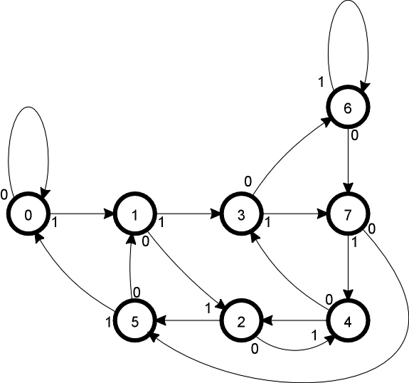
Finite State Diagram for Generator Polynomial 1011

Check- Bad The Algorithm:
Sum Bit
1 Compose a 4 bit message
1 | 7
2 | 6
3 | 4
4 | 5
5 | 1
6 | 3
7 | 2
2. Append 3 zeros
3 Traverse the FSD to determine the checksum
4 Append the checksum onto the end of the message
5 Send the Message – lose 1 bit
6 Receive the message
7 Traverse the FSD to determine the checksum
8 Error Correction Table[checksum] is the position of the bad bit
Error Correction
Table for 1011

